**CHAPTER 4**

**RESULTS**

**Initial screen:**

The window contain seven buttons: add product, update product, remove product, Check stock levels, search and view product, display summary, exit shown in figure 4.1

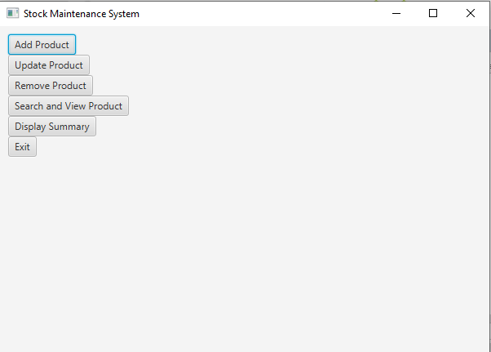

**Fig 4.1: Home Page**

**Add product:**

Clicking on the “add product” button opens a new window titled “Add product form” as shown in figure 4.2, 4.3.

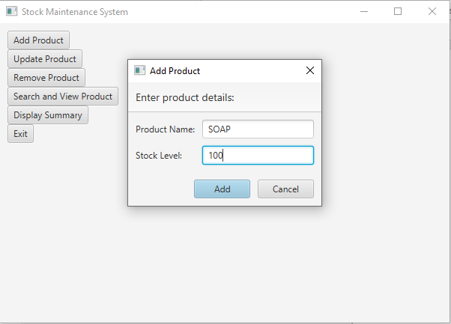

**Fig 4.2: Add Product**

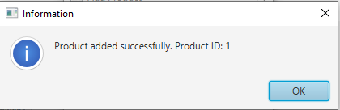

**Fig 4.3: product added**

**Update the product:**

Clicking on the “update product” button opens a new window titled ”update product” ,as the window display the current number of updates as shown in figure 4.4, 4.5.

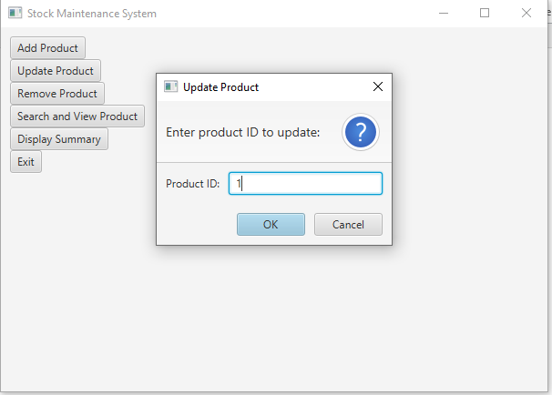

**Fig 4.4: Update**

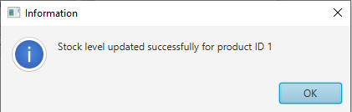

**Fig 4.5: Product Updated**

**Remove the product:**

clicking the “remove product” button open a new window titled “remove product”.as the window shown found are not and also remove the product are shown in figure 4.6, 4.7.

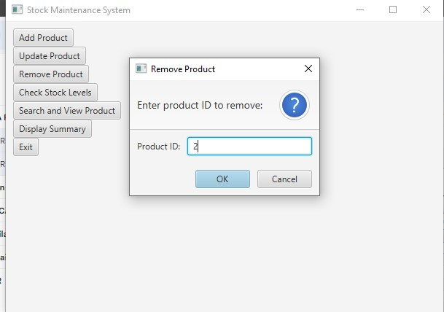

**Fig 4.6: Removing The Product**

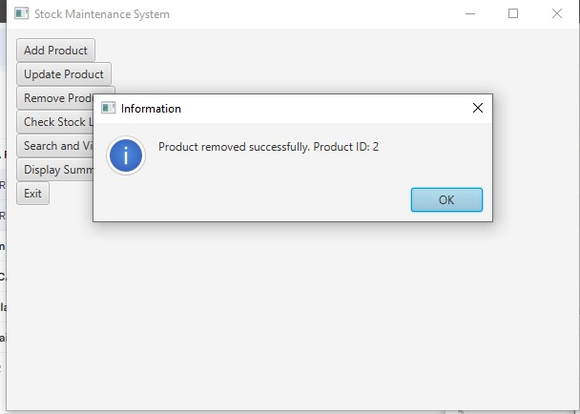

**Fig 4.7: Product Removed**

**Search and view**

To search and view the needed item from the inventory and display the information as shown in figure 4.8.

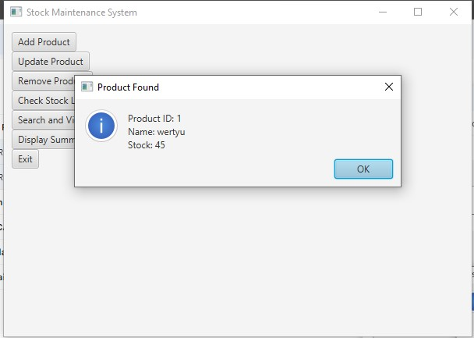

**Fig 4.8: Search and view product**

**Display Summary**

To display all the items in the inventory in a grid view as shown in fig 4.9.

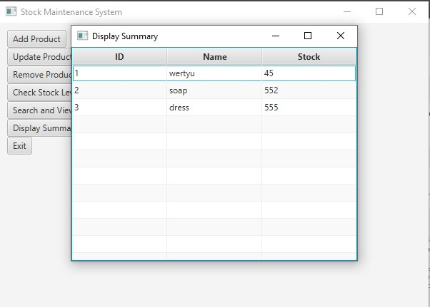

**Fig 4.9: Display products**

**Exit**

After clicking the exit button the page would be closed.